|  |
| --- |
| Instructional Guide for C347 |

Contents

[Read up 1](#_Toc511344156)

[Git installation 1](#_Toc511344157)

[Importing into Github (initial commit) 5](#_Toc511344158)

[Commit changes to repository 8](#_Toc511344159)

[Update changes from the repository 12](#_Toc511344160)

[Import a project from Github 13](#_Toc511344161)

## Read up

1. Sign up for an account @ <https://education.github.com/pack>

Do remember to use the RP student email account.

1. Some initial read up on GitHub to understand the various operations that can be done using it

<https://guides.github.com/activities/hello-world/>

<http://rogerdudler.github.io/git-guide/>

<http://www.vogella.com/tutorials/Git/article.html>

<https://code.tutsplus.com/tutorials/working-with-git-in-android-studio--cms-30514>

## Git installation

**Step 0** - Installation file preparation

Copy from the file PortableGit-2.16.2-64-bit.7z.exe, from the class lecturer

Alternatively, you can download it at <https://github.com/git-for-windows/git/releases/download/v2.16.2.windows.1/PortableGit-2.16.2-64-bit.7z.exe>

**Step 1** - Installing Git

Run the installation file from Step 0

Portable Git for Windows 64-bit 
This archive effacts a complete Git for Wndows 64bit 
Where do you want to install portable Git? 
__I 

Do choose to install Git at the folder created for Android IDE installation. For example, D:\Android\PortableGit

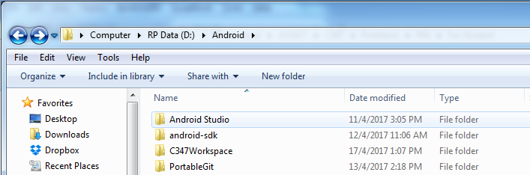

\*Note: After the Git installation, your D:\Android should contain the above 4 folders.

**Step 2** - Setting up Git in Android Studio

1. Go to the **Settings** page. It can be accessed from the main starting screen shown below

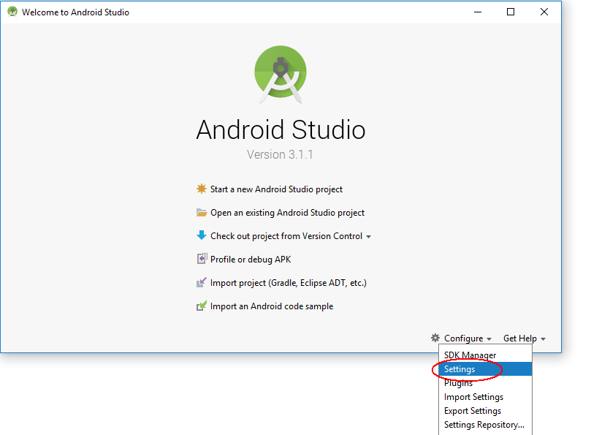

Alternatively, the **Settings** page can be accessed from here too!

MyAppIication - 
Edit View 
Open... 
Open Recent 
Close Pro ect 
Settings... 
- build.c 
Navigate Code Analyze Befactor Ruild Run 
'ity_main.xml x 
cture... 
Other Settings 
Import Settings... 
Export Settings... 
Settings Repository... 
Save All 
Si'nchronize 
Ctrl+AIt+Shift+S 
Ctrl+S 
Ctrl+A1t+Y 
Invalidate Caches / Restart... 
Print... 
Power Save Mode 
apply plugin : 
android 
compile SdkVers 
IsVe 
de f au ItCon f ig 
applicatic 
min SdkVe 
target Sd 
vers Ion 
ve s icnN 
test Instru 
bu i IdTypes 
release 
min 

1. Enter the path to the **git.exe** from the Git installation at Step 1

Settings 
Appearance & Behavior 
Version Control 
Confirmation 
Background 
Ignored Files 
Issue Navigation 
Changelist Conflicts 
GitHub 
Mercuria 
Subversion 
Build, Execution, Deployment 
Languages & Frameworks 
Version Control Git 
For current project 
Path to Git executabl 
SSH executable: 
Built- In 
Commit automatically on cherry-pick 
Warn if CRLF line separators are about to be committed 
Warn when committing in detached HEAD or during rebase 
Update method: Branch default 
Auto-update if push of the current branch was rejected 
Allow force push 
Protected branches: 
Cancel 
master 
Apply 
Help 

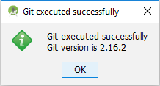

1. Next, do enter the Github account credentials in the Github entry

Settings 
Appearance & Behavior 
Version Control 
Confirmation 
Background 
Ignored Files 
Issue Navigation 
Chan elist Conflicts 
GitHub 
Mercurial 
Subversion 
Build, Execution, Deployment 
Languages & Frameworks 
Version Control GitHub 
For current project 
github.com 
Login: 
Passwor 
Do not have an account at githubzom? 
Auth Type: 
Clone git repositories using ssh 
Connection timeout: 
Cancel 
Passwo rd 
Apply 
Help 

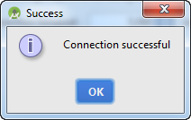

## Importing into Github (initial commit)

**Step 1** - Create an Android project in Android Studio or choose any existing project to be imported

**Step 2** - At the VCS menu, choose Import into Version Control -> Share Project on Github

IC347Workspace\MyFi rstGit] ap 
Code Analyze Befactor 
- Android Studio 23.1 
guild 
com 
Run Tools 
app 
myappl 
activity_l 
vcs 
Window Help 
Local History 
Enable Version Control Integration... 
main Java 
VCS Operations Popup... 
Apply Patch... 
Alt+8ack Quote 
Ipplicationdev.android.myfirstgit 
ainActivit,' 
'pplicationdev.android.myfirstgit (and 
Ipplicationdev.android.myfirstgit (test 
Apply Patch from Clipboard... 
Checkout from Version Control 
Import into Version Control 
Browse VCS Repository 
Sync Settings 
@Cverride 
7 
tivit,' 
tgit; 
Import into CYS... 
Create Git Repository... 
Import into Subversion... 
Share Project (Subversion)... 
protected onCreate (Bundle savedll 
. Share Project on GitHub 
super. cnCreate ( s avedInstanceSta 
setContentView (R. Layout. activi ty 

**Step 3** - Project creation and upload @ Github

1. With the Github settings done prior to this, you would be seeing the below window

Share Project On GitHub 
New repository name: MyFirstGit 
Remote name: 
Description 
origin 
Just a test project . 
Share 
Cancel 
Private 
Help 

You can leave the remote name as the default value. As for the description, do input something useful and descriptive of your project. This could be your portfolio :)

1. The following window will pop up, showing the files going to be committed to the repository

Add Files For Initial Commit 
app 21 files 
ExampleInstrumentedTest.Java 
main 
MainActlvlty.Java 
layout 
activity_main.xml 
mipmap-hdpi 2 
ic_launcher.png 
mipmap- mdpi 2 
Commit Message 
nitial commit 

The commit message is supposed to capture the changes done for every commit. Do note that *commit* is not referring to "save" in your Android Studio. The *commit* is akin to the closing of sales of a day or whenever there's something major.

1. You can just click "no" for this pop up window. Basically, we would want to commit only essential files, transient files are not required.

Transient files here are referring to files that are generated by the IDE pertaining to user specific settings, definitely not critical to the project.

Add File to Git 
Do you want to add the following file to Git? 
If you say No, you can still add it later manually. 
Remember, don't ask again 

Note: To know which are not required to be committed into a repository, you can refer to this template <https://github.com/github/gitignore/blob/master/Android.gitignore>

You can also copy its content into .gitignore of your project to automate file exclusion

1. Upon completion, you'll see this pop up box on the lower right.

o 
Successfully shared project on GitHub 
MyFirstGit 
CRLF: 
UTF-8: 
Event Log 
Ccntext: 
Git master: 
Gradle Console 
nc cc:ntexO 

1. Go to <http://github.com> with your account logged on, you'll see the repository is created and the files are committed in it.

Search GitHub 
Pull requests 
Issues 
Gist 
Learn Git and GitHub without any code! 
Using the Hello World guide, you'll create a repository, start a branch, 
write comments, and open a pull request. 
Read the guide 
Start a project 
Discover interesting projects and people to populate 
your personal news feed. 
Your news feed helps you keep up with recent activity on repositories you watch 
and people you follow. 
Explore GitHub 
(CO) Restrict review dismissals with 
protected branches 
You can ncw restrict who is able to dismiss 
reviews on your protected branch. 
View 3 new broadcasts 
New repository 
eso 
Find a repository... 
ublic 
Private 
MyFirstGit 
P03-Problem 
Sources 
Forks 

## Commit changes to repository

1. Code changes

package com.myapplicationdev.andmid.myfirstgit; 
import 
public class MainActivity extends AppCompatÄctivity 
r ride 
protected onCreate (Bundle savedInstarn:eState) 
super. cnCreate (savedInstanceState) ; 
setContentView (R. Layzut. activi ty main) ; 
//This is nev line 

As you make changes to the project on the Android Studio, the IDE is keeping track of what you have written. The changes will be saved in your local storage as you continue on your development.

Only when you are ready to *commit*, you will need to push the changes into the repository.

Eile Edit View Navigate Code Analyze Befactor Ruild 
MyFirstGit - - [app]-..\app\src\main\java\com\myappIicationdev\android\myfirstgit\MainActivity.java - An 
Run Tools 
caapp 
My FirstGit 
main Java 
Android 
ma nifests 
com 
com.myapplicationdev.android.myfirstgit 
(e) MainActivit,' 
com.myapplicationdev.android.myfirstgit (and 
com.myapplicationdev.android.myfirstgit (test 
Gradle Scripts 
vcs 
Window Help 
Local History 
Commit Changes... 
Integrate Project... 
Refresh File Status 
Create Patch... 
Apply Patch... 
Apply Patch from Clipboard... 
Shelve Changes... 
Checkout from Version Control 
Import into Version Control 
Browse VCS Repository 
Sync Settings 
It+8ack Quote 
tivit,' 
Ctrl+T 
tgit; 
ivity 

The following screen will appear. It's a necessary practice to summarize the code being committed. The idea is to capture the essence of what is being committed into the repository.

Notice that vcs.xml is unchecked since the file is not required to be committed.

Commit Changes 
• app 
Change list: Default 
MainActivity.java 
Unversioned Files I file 
v MyFirstGit 
idea 
vcs.xml 
Modified: I 
Commit Message 
dded comments to MainActivit,' 
Details 
Unversioned: O of I 
Author: jason-lim rp 
Amend commit 
Before Commit 
Reformat code 
Rearrange code 
Optimize imports 
Peform code analysis 
Check TODO (Show All) Configure 
Cleanup 
Update copyright 
Commit 
Cancel 
Help 

To effect the changes to the remote repository (in this case, Github itself), you need to push the changes over.

- Android Studio 23.1 
vcs 
Window Help 
Local History 
VCS Operations Popup... 
'appl 
Commit Changes... 
.'ity_l 
+ Update Project... 
Integrate Project... 
Refresh File Status 
Create Patch... 
Apply Patch... 
Alt+8ack Quote 
Ctrl+K 
Ctrl+T 
tgit; 
Apply Patch from Clipboard... 
Shelve Changes... 
Checkout from Version Control 
Import into Version Control 
Browse VCS Repository 
Sync Settings 
'2017 12:53 AM 
Q: Messages 
Commit File... 
Ctrl+Alt+A 
An notate 
Show Current Revision 
Compare with the Same Repositorz Version 
Compare with Latest Repository Version 
Compare with... 
Compare with Branch... 
Show History 
Show History for Selection 
Revert... 
Resolve Conflicts... 
Branches... 
Tag... 
Merge Changes... 
Stash Changes.. 
UnStash Changes... 
Reset HEAD... 
Clone... 
Fetch 
Rebase... 
Rebase my GitHub fork 
Create Pull Request 
Ctrl+AIt+Z 

1. File adding/removal

Whenever you add a new file, Android Studio will prompt if you want to add to Git.

Add File to Git 
Do you want to add the following file to Git? 
D: n dr C347W 
If you say No, you can still add it later manually. 
Remember, don't ask again 

\*Note: At this point, it is marked to be added to the repository. However, the real adding is only when you commit into the repository.

To commit the new file, choose commit changes from the VCS menu. The screen below will appear and do provide the summary for the commit as well.

Commit Changes 
• app 
Item.java 
Unversicned Files I file 
C mit Message 
dded a new Java file - Item.jgye 
Details 
Change list: Default 
New: I Unversioned: O of I 
Author: jason-lim rp 
Amend commit 
Before Commit 
Reformat code 
Rearrange code 
Optimize imports 
Peform code analysis 
Check TODO (Show All) Configure 
Cleanup 
Update copyright 
Commit 
Cancel 
Help 

After which, you need to push the changes over to Github

## Update changes from the repository

1. To update changes to the code from the repository, you can choose update from the CVS menu

Eile Edit View Navigate Code Analyze Befactor Ruild 
MyFirstGit - - [app]-..\app\src\main\java\com\myappIicationdev\android\myfirstgit\MainActivity.java - 
Run Tools 
myappl 
caapp 
My FirstGit 
main Java 
Android 
ma nifests 
com 
vcs 
Window Help 
Local History 
VCS Operations Popup... 
Update Project... 
Refresh File Status 
Create Patch... 
Apply Patch... 
Alt+8ack Quote 
tivit,' 
Ctrl+K 
tgit; 
ivity 
com.myapplicationdev.android.myfirstgit 
Item 
MainActivit,' 
com.myapplicationdev.android.myfirstgit (and 
com.myapplicationdev.android.myfirstgit (test 
Gradle Scripts 
Apply Patch from Clipboard... 
Shelve Changes... 
Checkout from Version Control 
Import into Version Control 
Browse VCS Repository 
Sync Settings 

This is useful if you happen to use 2 different laptops to develop a project. Or the project is jointly developed by multiple authors.

1. Due to the projects can be located in a distributed manner, a Github project can be cloned to many different locations or by different collaborators. As the different local repo can be accessed and modified independent of one another some concurrency issue might be raised.

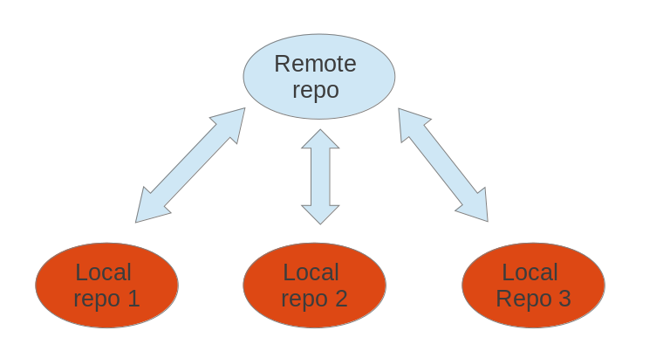

There's a possibility that there will be a conflict during update or commit. A conflict is due to changes made to the repository from the last time your copy of the project was updated.

This could happen when there are more than 1 contributor/author for the project and they are making changes concurrently over the same period. Example, in a day, both authors tries to commit the same file.

When a conflict happens, it can be due to the following:

i) There are changes to the code in the repository since the last time you updated your local code

ii) Multiple collaborators doing some changes to the same file

1. Resolving conflicts

You need to resolve the conflict. Typically, a window like this might show up. This is for you to decide which version of the code to keep.

Machine generated alternative text:
Merge Revisions for D 
Uncommitted changes from stash (Read-only) 
package com.myapplicaticndev 
Created by jäson on 
public class Item 
String name ; 
int age; 
String producer ; 
oft a 
14 
CRLF 
package com.myapplicaticndev.and 
Created by jäson on 17/ 
public class 
I tem 
Str ing 
in t 
age ; 
I change. I conflict 
Changes from Remote 
package com.myapplicaticndev 
Created by jäson on 
public class Item 
String name ; 
int age; 
int year ; 
Abort 
Result 
Accept Left 
Accept Right 

There will be times, the Android Studio will just prompt for merge. That's to merge your changes to the changes another collaborator has done, before you commit your code and after you check out the project.

Machine generated alternative text:
Push Rejected 
Push of current branch master was rejected. 
Remote changes need to be merged before pushing. 
Remember the update method choice and silently update in future 
(you may change this in the Settings) 
Cancel 
Rebase 

Machine generated alternative text:
Files Merged with Conflicts 
Merge conflicts detected. Resolve them before continuing update. 
Theirs 
Accept Yours 
Modified 
Accept Theirs 
Close 
Name 
CI Item.java (D:XAndrcicIXC347'eVcrkspaceXMvFirstG Text 
Yours 
Modified 

The idea is to look at the changes and to decide whether to keep your copy, other's copy or merge the code.

## Import a project from Github

To check out a project from the Github, it's quite straight forward as the Android Studio has an option for it.

Welcome to Android Studio 
Android Studio 
Version 23.1 
Start a new Android Studio project 
Open an existing Android Studio project 
Check out project from Version Control • 
Import project (Eclipse ADT, Gradle, etc.) 
Import an Android code sample 
Configure • 
Get Help • 

What you need is the link to the project on Github as well as where do you want to store the project.

Clone Repository 
Git Repository URL: https://github.com/jason-Iim-rp/RPA it 
parent Directory. 
Directory Name: 
RPApp 
Clone 
Cancel 
Help 